TECHNICAL STANDARD OPERATING PROCEDURE
CREATING A NEW WINDOWS SERVER 2016 INSTANCE ON VMWARE Workstation
Prepared by: Capgemini India
For Client: Lars & Toubro (L&T)

Document Version / Revision History
Version | Revision Date | Status & Description | Author | Reviewer | Remarks
1.0 | 08/10/2026 | Initial Draft: Windows Server 2016 basic setup procedure on VMware. | Aditya Raorane | Hemant Jatal | Initial Submission

Table of Contents
1. Preface.................................................................................................................................................................................... 4
2. Document Content Overview................................................................................................................................... 4
3. Resource Requirements............................................................................................................................................. 4
3.1 Hardware Resource Allocations.......................................................................................................................... 4
3.2 Software & ISO Requirements............................................................................................................................. 4
4. Operational Prechecks................................................................................................................................................. 4
5. Actual Procedure: Step-by-Step Guide............................................................................................................. 5
6. Post-Activity Infrastructure Checks...................................................................................................................18
7. Verification & Deliverables Confirmation...................................................................................................... 18
8. Conclusion........................................................................................................................................................................ 19
9. Official References & Licensing Links............................................................................................................ 20

1. Preface
This technical document establishes the standard operating procedure for deploying a Windows Server 2016 instance within the VMware workstation enterprise environment. This framework guarantees operational alignment and architectural consistency across the infrastructure shared between Capgemini and Lars & Toubro (L&T).
2. Document Content Overview
This guide outlines the hypervisor configuration, virtual hardware provisioning, and operating system deployment required to establish an enterprise-ready Windows Server 2016 node. It details specific settings, interface prompts, and post-installation checklists necessary for baseline network integration.
3. Resource Requirements
3.1 Hardware Resource Allocations
- Compute: Minimum 2 vCPUs (Virtual Central Processing Units.
- Memory: Minimum 4096 MB (4 GB) vRAM (virtual Random Access Memory).
- Storage: Minimum 60 GB virtual disk space.
3.2 Software & ISO Requirements
- Hypervisor: VMware workstation 6.5 / 6.7 or newer managed via vCenter Client interface.
- Operating System: Official Microsoft Windows Server 2016 Standard Edition 64-bit ISO image file.
- ISO Integrity: SHA-256 verified media located in the global datastore ISO repository.
4. Operational Prechecks
- Verify target workstation has sufficient free RAM (minimum 8 GB uncommitted) and CPU capacity to handle the load.
- Confirm that the target L&T VLAN port group has DHCP enabled, or obtain an allocated static IP address, subnet mask, and default gateway from the network team.
- Ensure the official Windows Server 2016 ISO is uploaded, mounted in the VMware library.

5. Actual Procedure: Step-by-Step Guide
Step 1: Open the VMware Workstation interface and navigate to the main 'My Computer' tab to view the active virtual machine library dashboard.
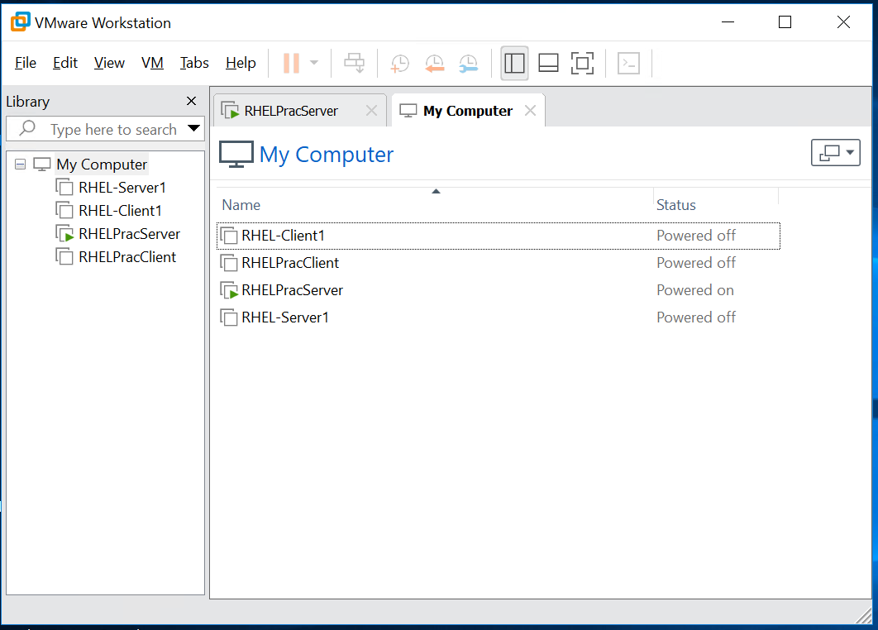
Step 2: Right-click on 'My Computer' in the left-hand Library pane and select 'New Virtual Machine...' to initiate the configuration wizard.
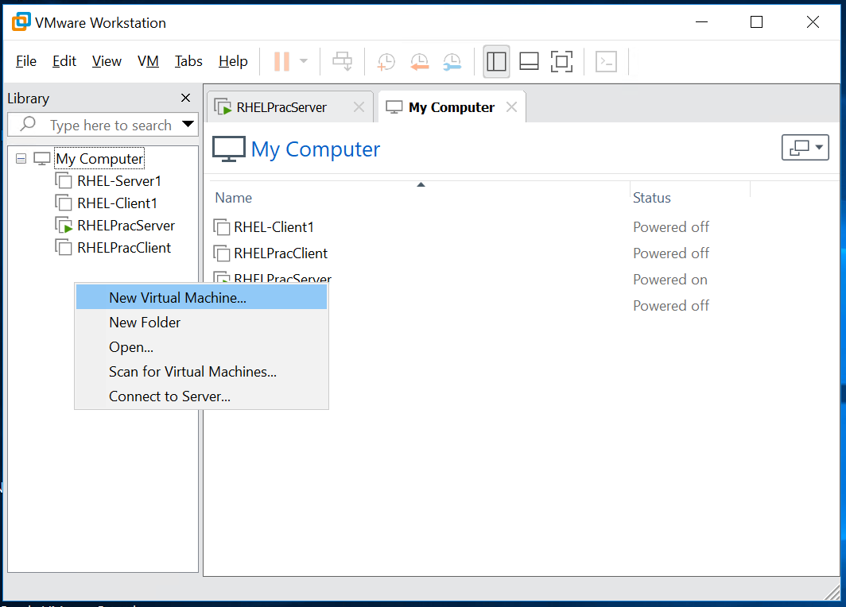
Step 3: Select 'Custom (advanced)' as the configuration type in the New Virtual Machine Wizard and click 'Next' to customize hardware settings.
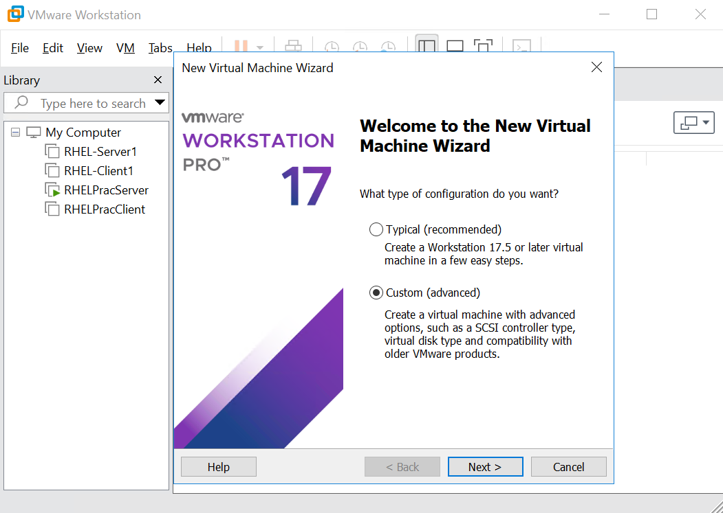
Step 4: Choose 'Workstation 17.5 or later' from the Hardware compatibility drop-down list to ensure full compatibility with modern features.
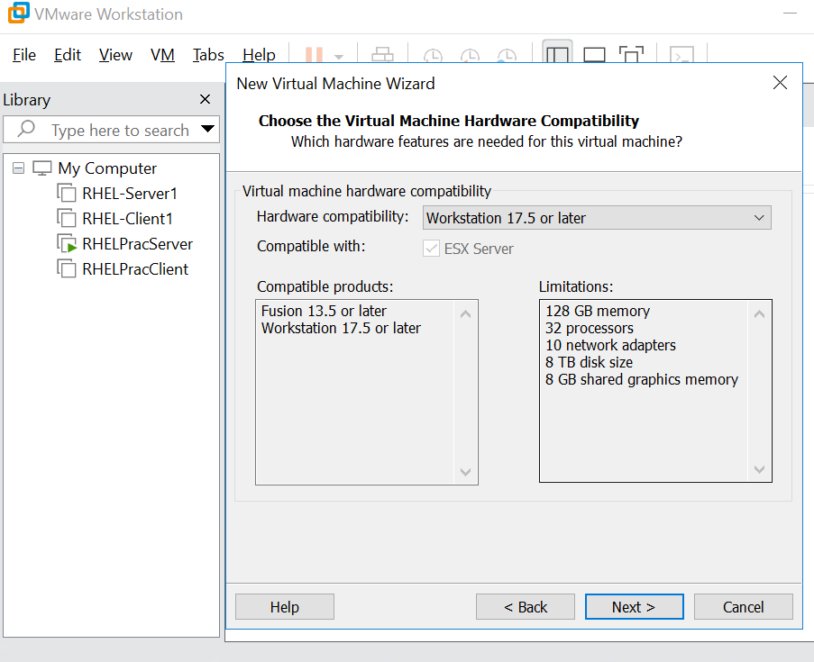
Step 5: Select the 'Installer disc image file (iso)' radio button, click 'Browse' to locate the official 'Windows Server 2016 D&S.iso' media, and click 'Next'.
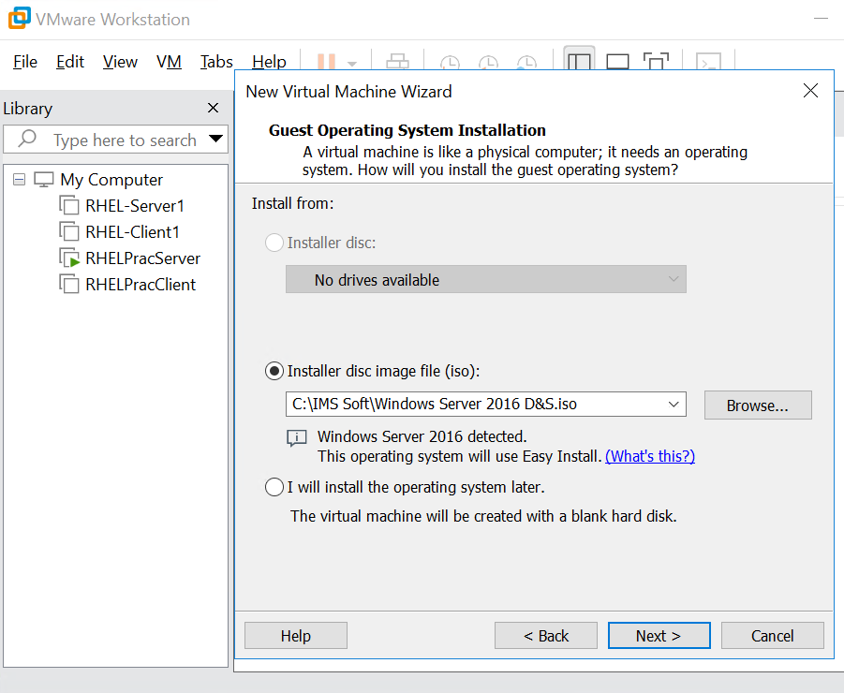
Step 6: Enter the version details, fill in the personalization fields with the full name (for e.g. 'm14'), set a secure administrator password, and click 'Next'.
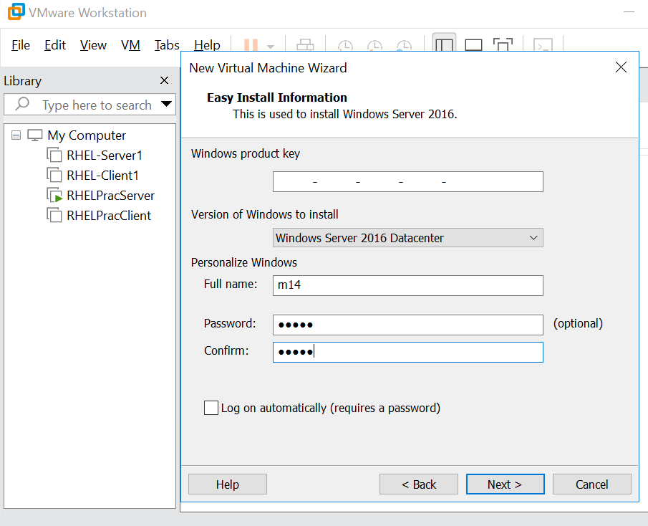
Step 7: Provide a distinct virtual machine name such as 'L&T_Windows_2016_VM' and define a dedicated storage directory path before clicking 'Next'.
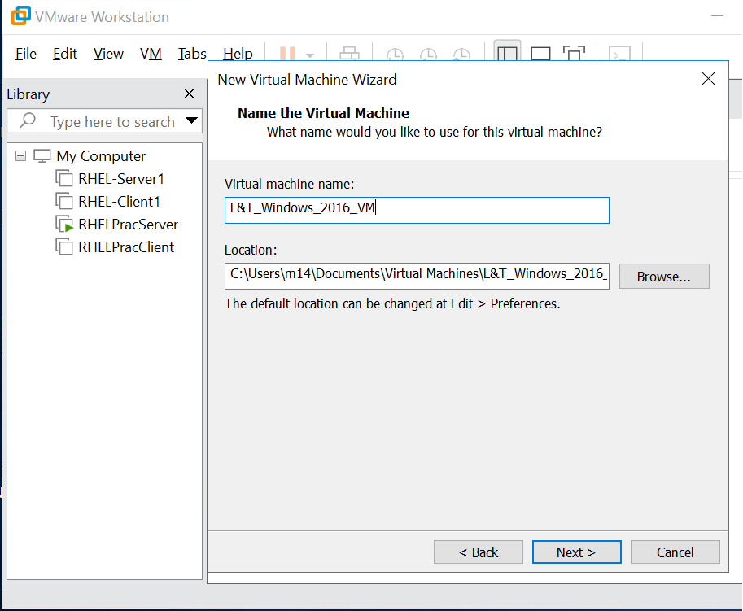
Step 8: Select 'BIOS' as the boot device firmware type for the guest operating system and click 'Next'.
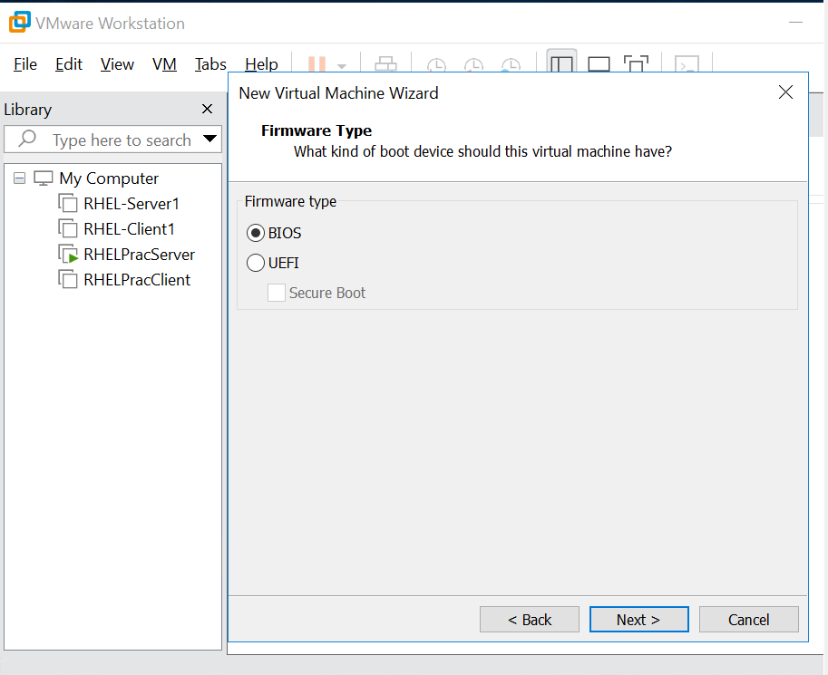
Step 9: Specify the processor configuration by setting the number of processors to '1' and the number of cores per processor to '1'.
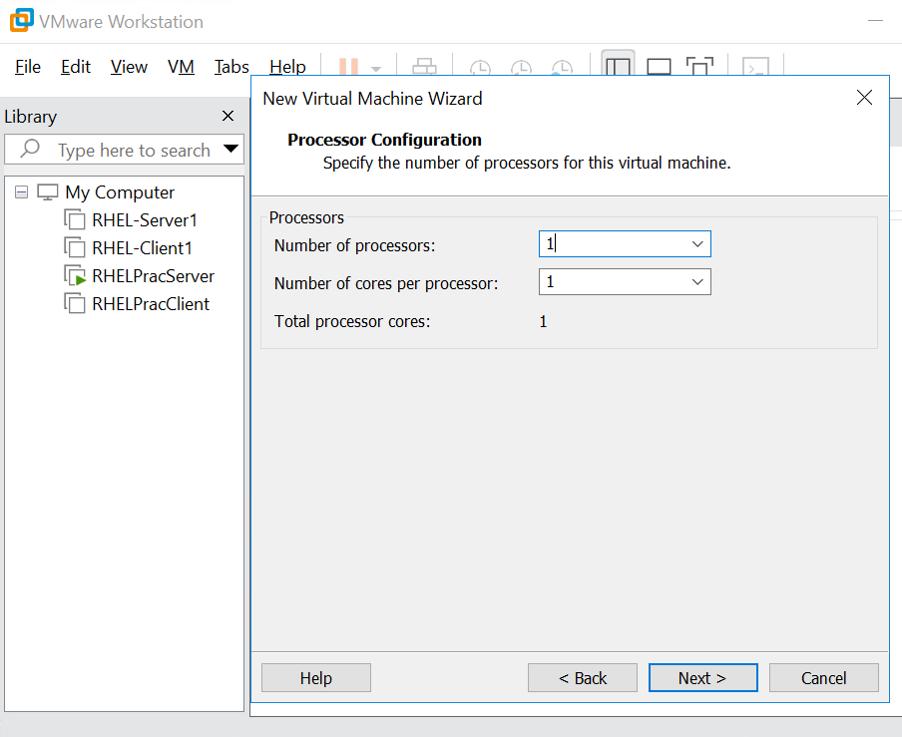
Step 10: Allocate memory for the virtual machine by adjusting the text field value to '8192 MB' (8 GB vRAM) and clicking 'Next'.
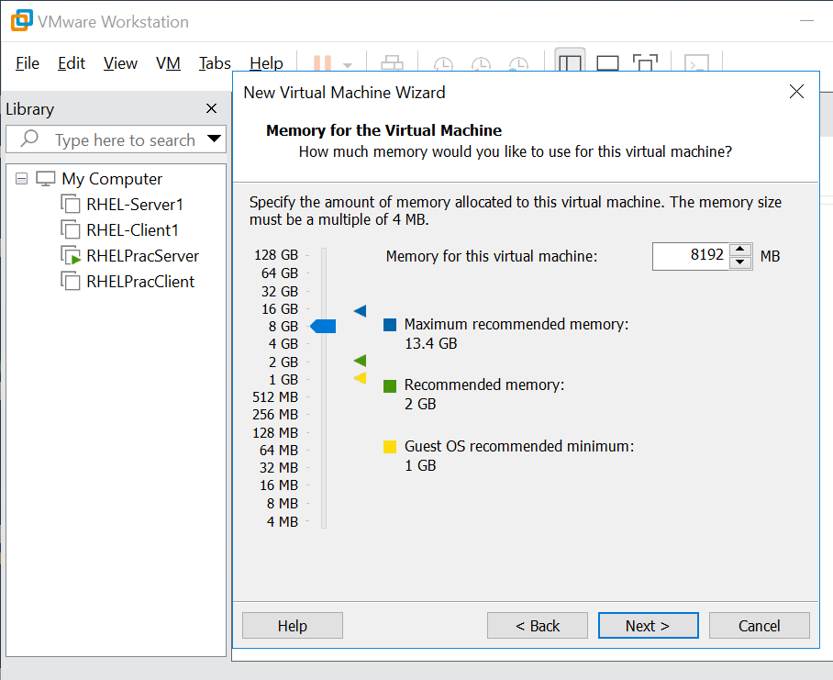
Step 11: Configure the network connection type by selecting the 'Use network address translation (NAT)' radio button option and clicking 'Next'.
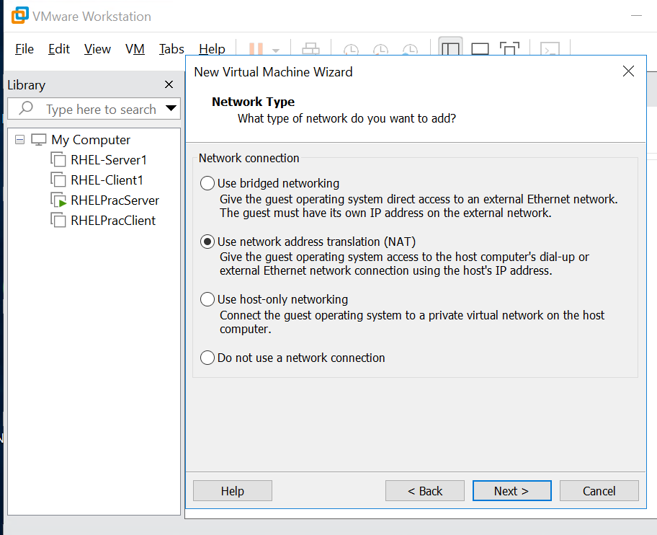
Step 12: Select the recommended 'LSI Logic SAS' option from the SCSI Controller I/O types list and click 'Next'.
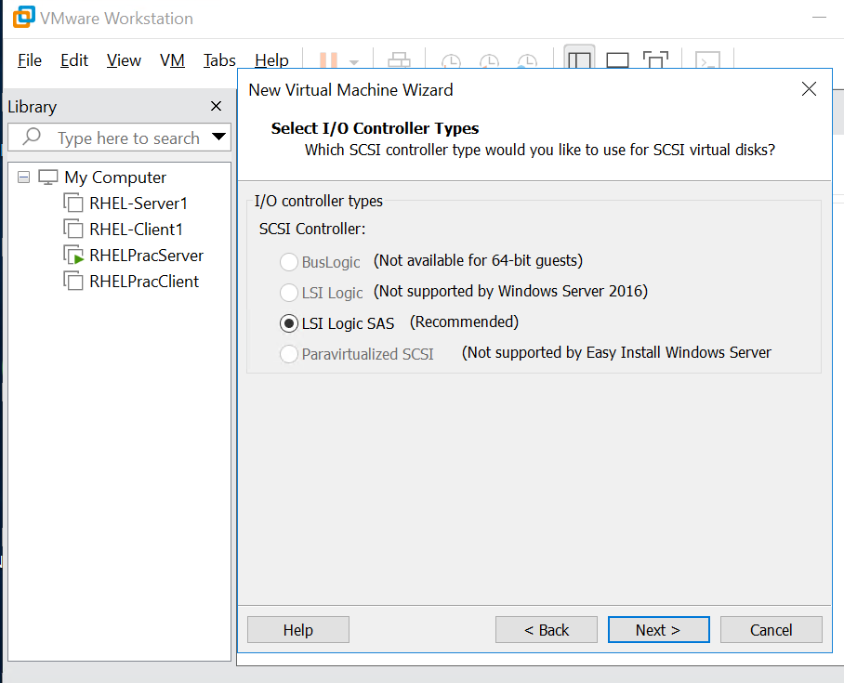
Step 13: Choose the 'Create a new virtual disk' option under the Select a Disk menu window to provision fresh virtual disk storage space.
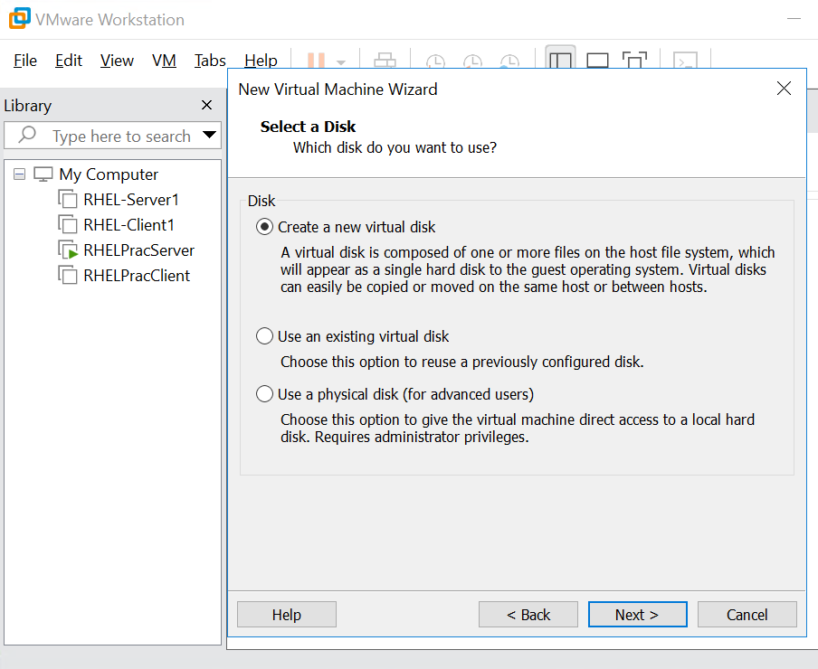
Step 14: Modify the Maximum disk size parameter to '100 GB', check the 'Store virtual disk as a single file' option, and click 'Next'.
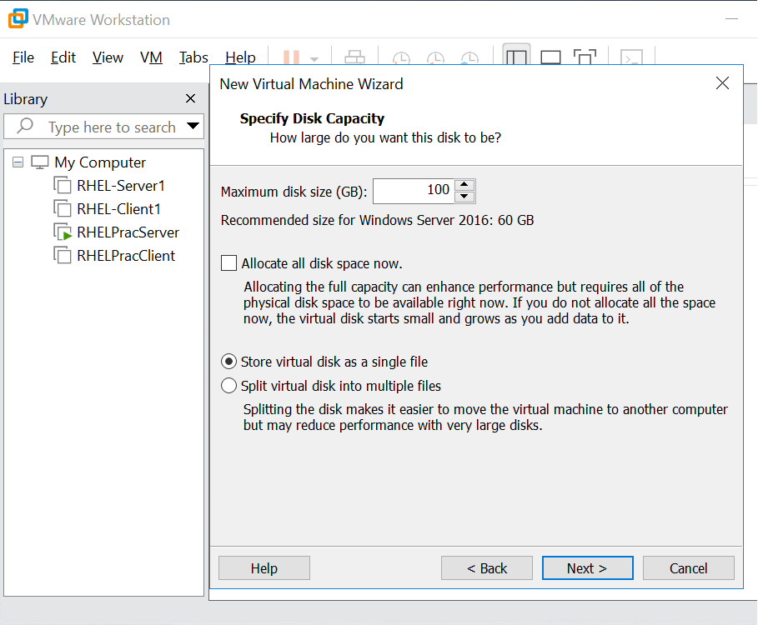
Step 15: Retain the default virtual disk file name format 'L&T_Windows_2016_VM.vmdk' in the path field prompt window and click 'Next'.
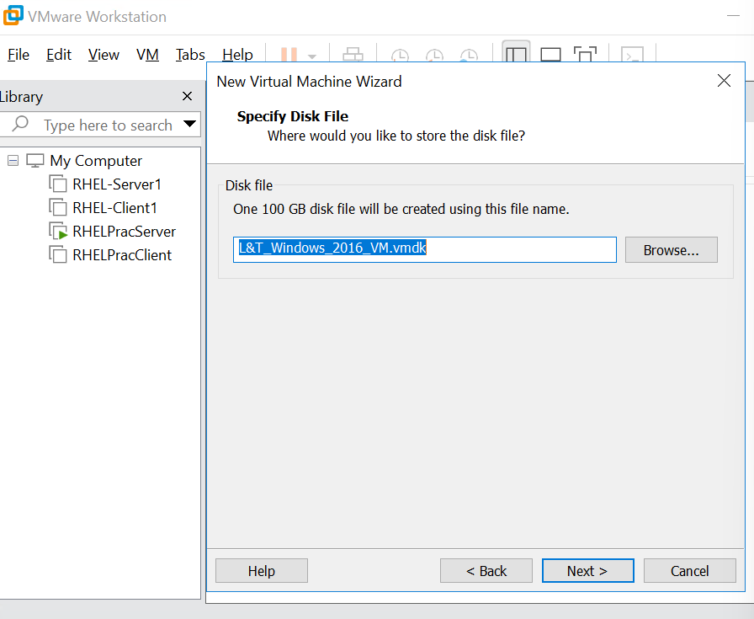
Step 16: Review the summary configuration panel list, ensure 'Power on this virtual machine after creation' is checked, and click 'Finish'.
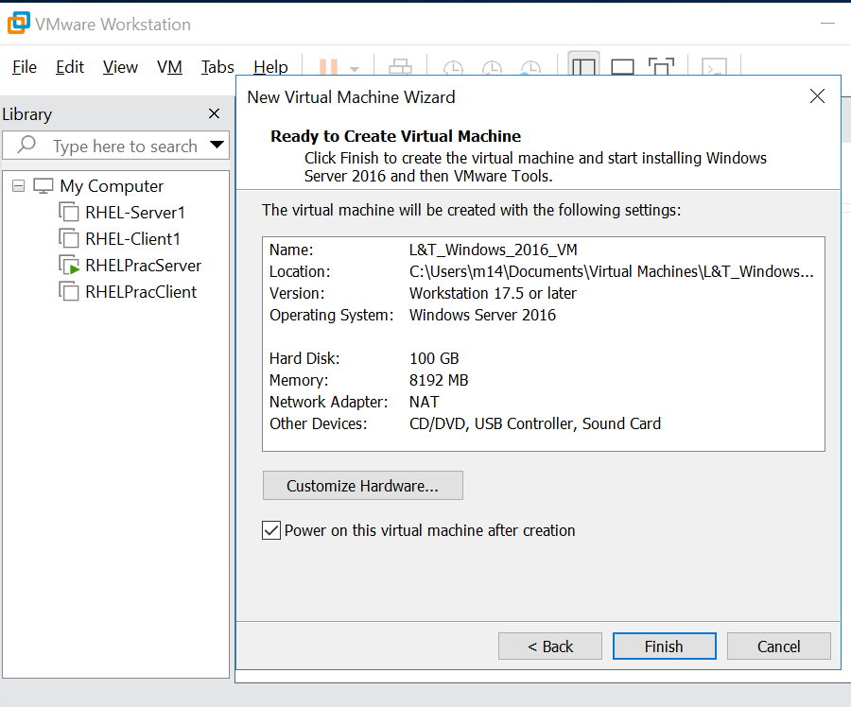
Step 17: Observe the active VMware hypervisor screen interface displaying the initial Windows Server OS loading animation sequence.
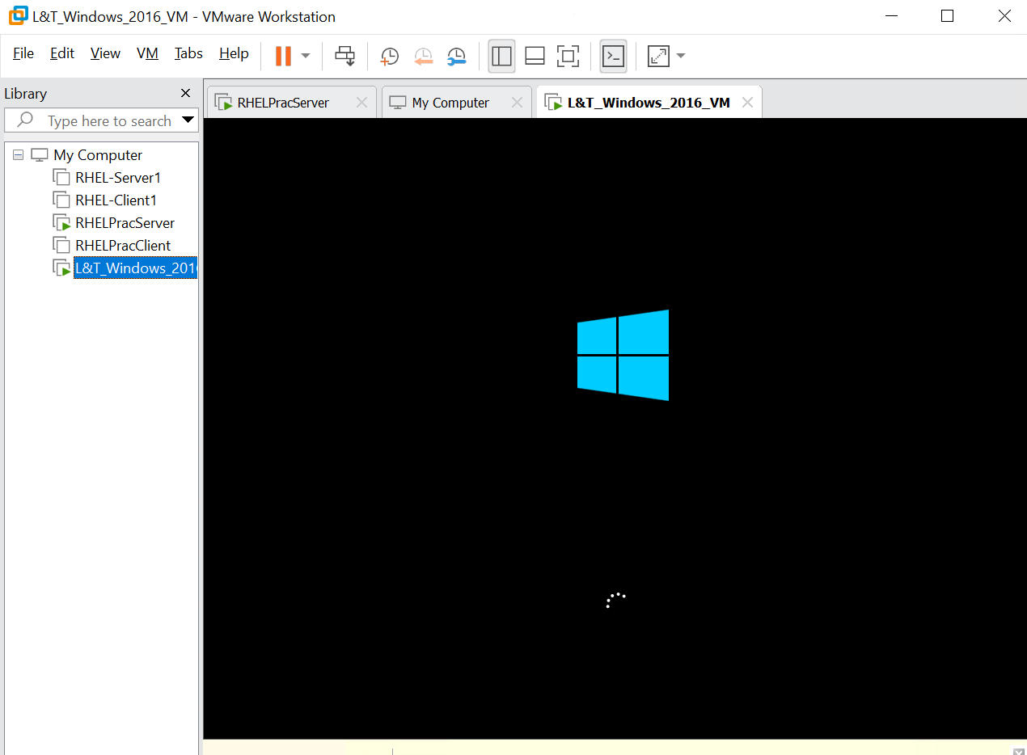
Step 18: Wait for the blue background interface to display the setup initialization string message prompt reading 'Setup is starting'.
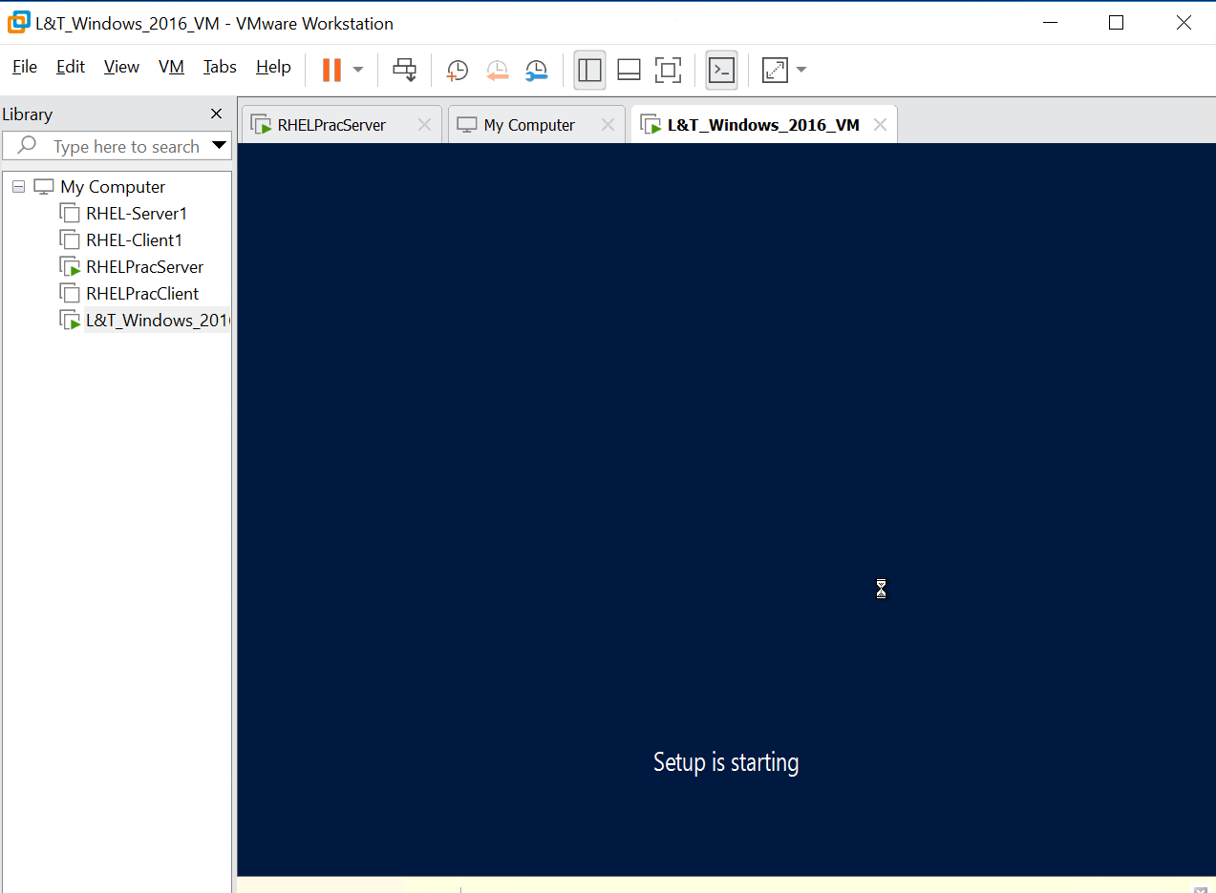
Step 19: Highlight the target operating system edition option row item 'Windows Server 2016 Datacenter (KMS)' from the installer menu list.
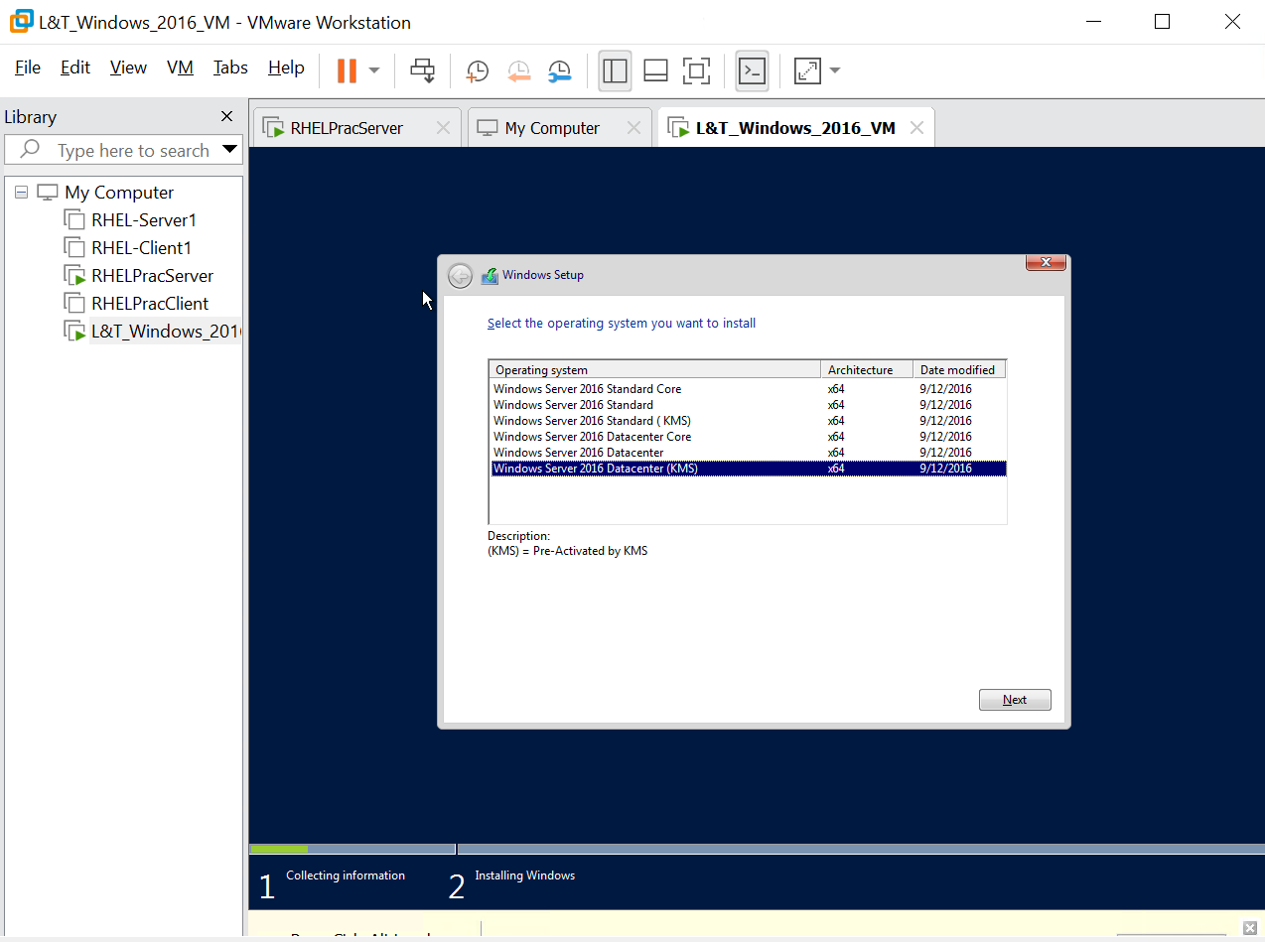
Step 20: Track the active operational progress status bar line item at the bottom of the wizard utility window screen pane.
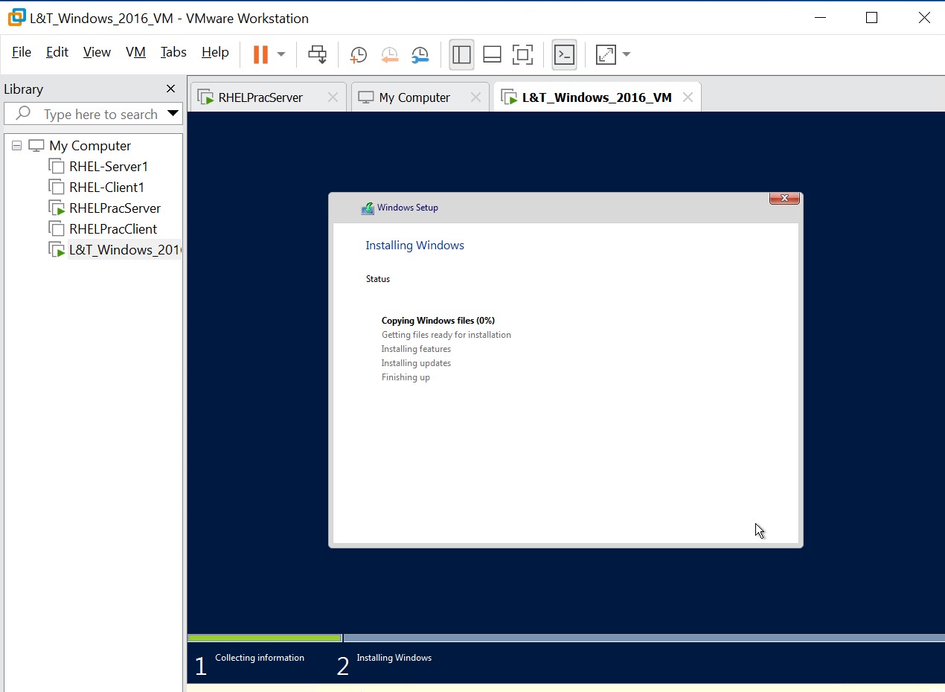
Step 21: Verify that the guest operating system completes its boot cycle successfully and opens the main system Server Manager Dashboard.
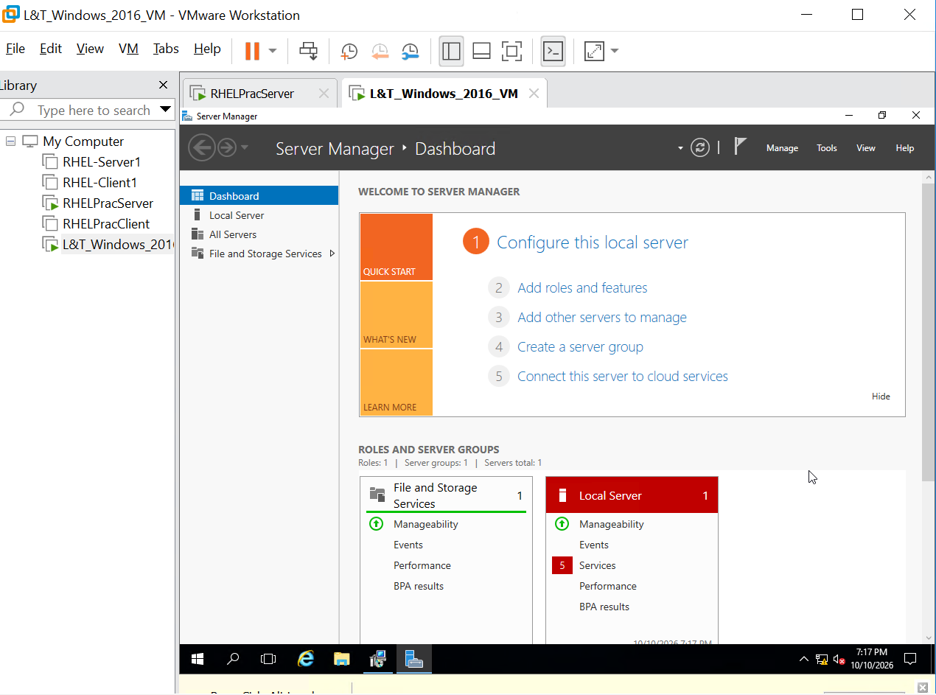
Step 22: Access the local Server properties view panel to verify the system attributes, initial workgroup string parameters, and active configuration settings.
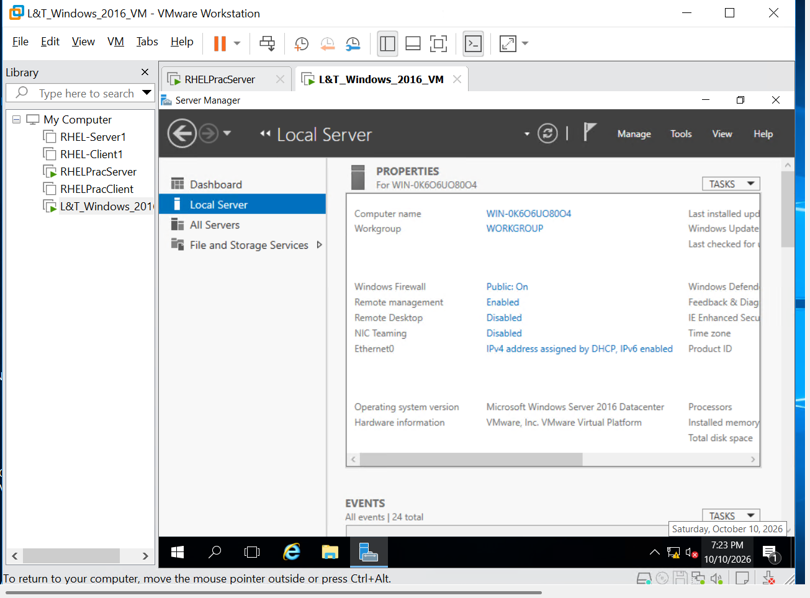
Step 23: Open the Internet Protocol Version 4 (TCP/IPv4) properties pop-up menu and choose 'Use the following IP address' to input static networking values.
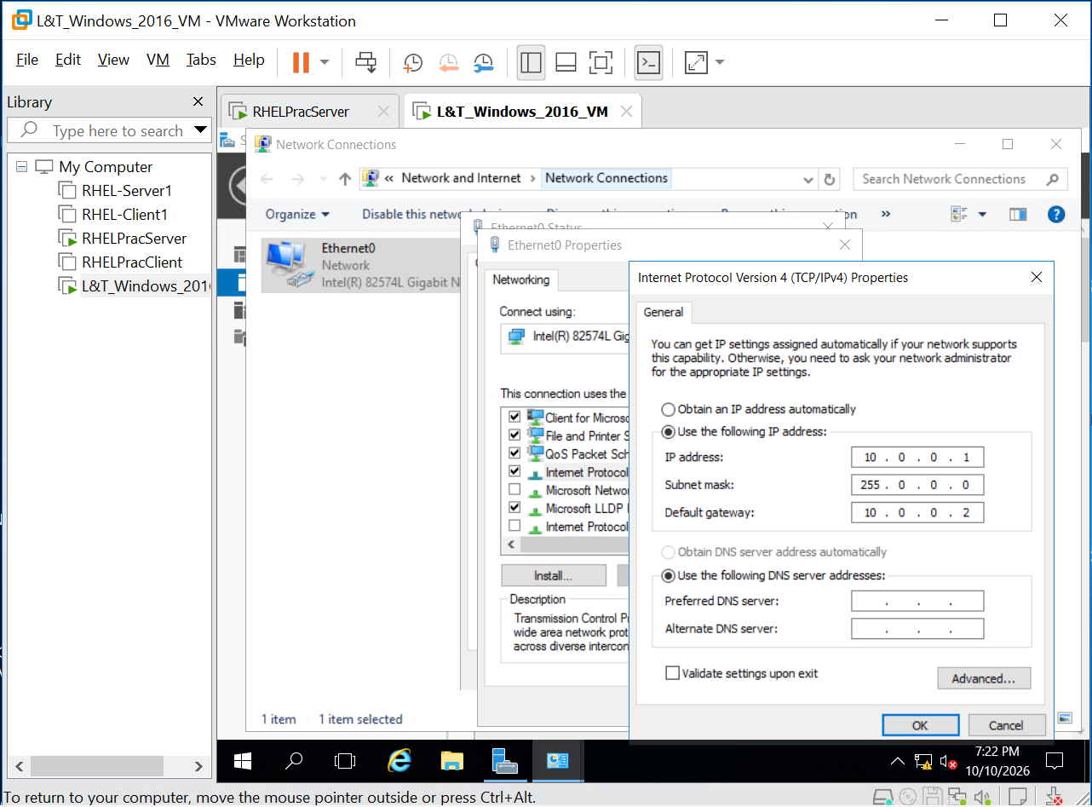
Step 24: Manually configure the static networking layout parameters by setting the IP address field values to '10.0.0.1' and the default gateway path to '10.0.0.2'. Refresh the page screen to see the saved configuration change.
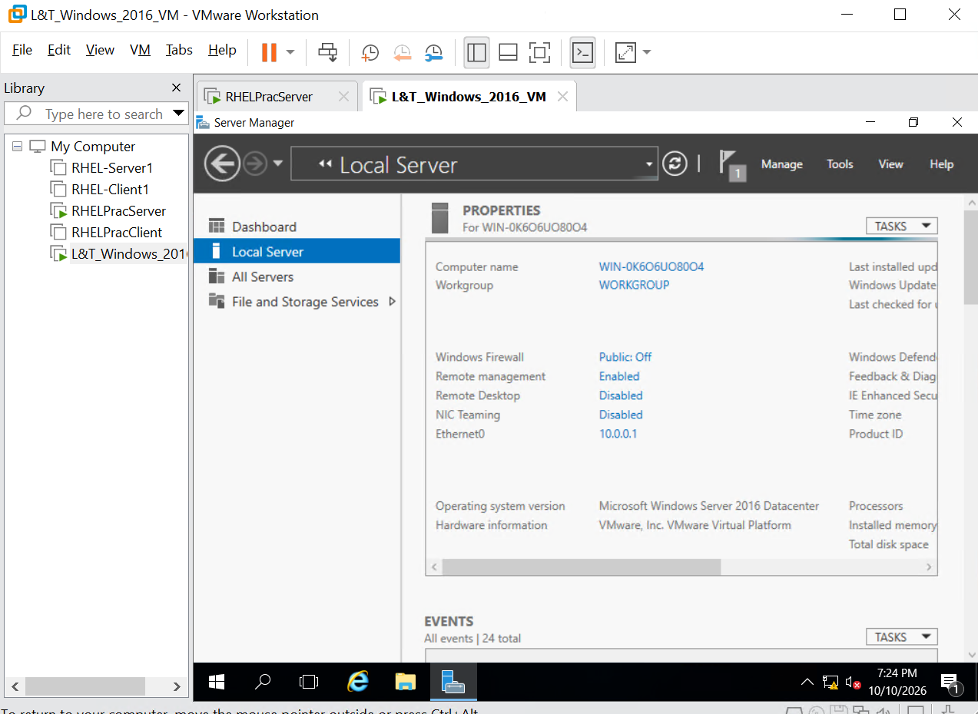
Step 25: Open the desktop interface search utility bar layout, input the string text key 'cmd', and select the 'Command Prompt' application.
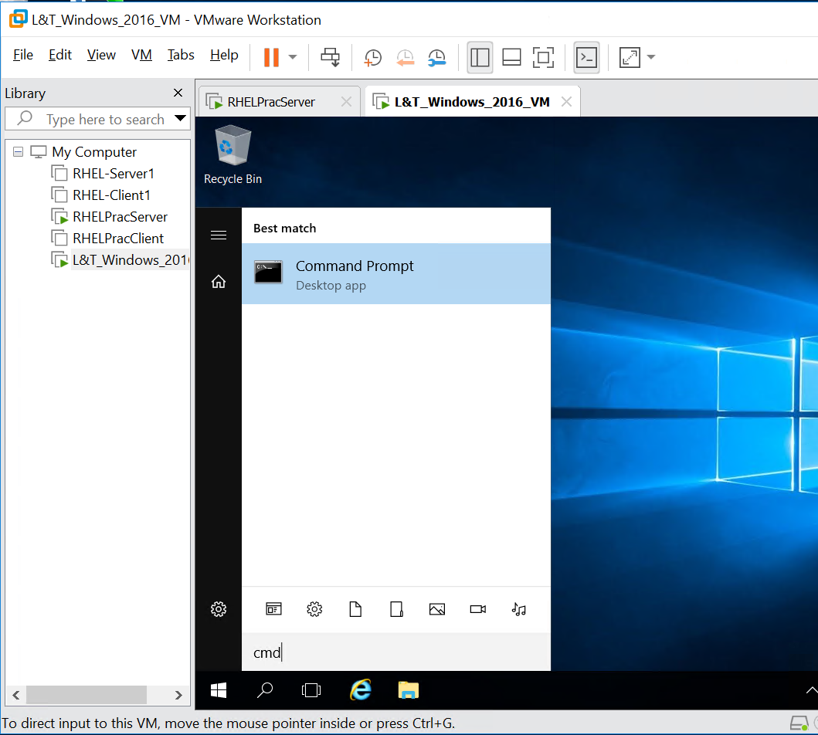
Step 26: Launch the administrative console panel window environment and run the troubleshooting ping script check command: 'ping 10.0.0.1'.
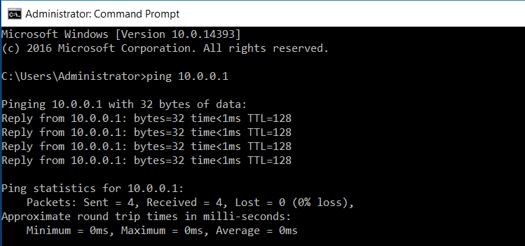

6. Post-Activity Infrastructure Checks
- Confirm the virtual machine completes its boot cycle successfully without throwing hypervisor errors or driver conflicts.
- Verify that the guest OS network settings are functional and that the machine can successfully ping the IP address of instance machine server itself.
7. Verification & Deliverables Confirmation
Final operational validation requires a confirmation snapshot showing the active Windows desktop environment alongside the running system configuration panel.
8. Conclusion
Following this procedure results in a fully functional, standard-compliant Windows Server 2016 virtual machine hosted on the L&T VMware infrastructure. The instance is immediately available for enterprise workload deployments, security hardening, and domain integration.

9. Official References & Licensing Links
- VMware Docs Portal (vmware.com): The official cloud architecture repository used to verify hypervisor guest OS compatibility matrix rules and virtual hardware standards.

